**Final Exam**

Problem 1

Ryan Watson

**Part A)**

**Statement of Problem:**

*Why do you think the authors are concerned with values such as $T_{0.001}$?*

*Give a formula for $T_{0.001}$ assuming the life length follows an exponential distribution with parameter $λ$.*

**Solution:**

According to the paper that this problem is based upon, **T** is the life length of a sample. So, knowing a value like $T_{0.001}$ *is* extremely valuable to any designer. This value allows the designers to replace a piece before a reliability threshold. So, for this specific example, we are concerned with $T_{0.001}$*.* This is the time that it would take for 1 out of 1000 samples to fail.

Since **T** is so usefulit would be valuable to have an equation to calculate it. To derive an equation for **T,** the assumption is made that the life-length follows an exponential distribution. Once that assumption is made, the cumulative distribution function is defined as

$F\left(t\right)= 1- e^{-λt}$.

Eq. 1

Where a linear relationship between the life-length and the cumulative distribution function exists such that,

T= $\frac{1}{λ}$ ln ($\frac{1}{1-F(t)}$) + $C_{0}$

Eq. 2

In Eq. 2, 1-F(t) is the probability that a sample does not fail up to and including t, and $C_{0}$ is the number of cycles of the first failure. So to calculate $T_{0.001}$**,** for this data set, you would set

$T_{0.001}$**= $\frac{1}{0.0007123}$**  * ln($\frac{1}{0.999}$) +370

**=** 371.4 ${10}^{3}$* Cycles

**Part B)**

**Statement of Problem:**

Using the form of the gamma distribution derived in class and the method of maximum likelihood, derived equations 4.1.2 and 4.1.3. Using the numbers found by the authors, what are the corresponding values of our parameters?

**Solution**:

The equation that was derived in class to describe the probability density function of a gamma distribution is shown below as Eq. 3.

G(t | ) = (

Eq. 3

The likelihood function of Eq. 3 is

L = $\sum_{i=1}^{N}{(-ln⁡(} Γ(γ))+(γ-1)ln⁡( λt_{i}$) + ($-λt )+ln⁡(λ$) ).

Eq. 4

The maximum likelihood equations can be obtained by taking the partial derivatives of Eq. 4 with respect to $γ and λ$ and setting them equal to zero. To find the estimate for $γ$, reference 1 was used. In this reference it states that

$γ^{-1}=\ln\left(γ\right)- \frac{Γ'(γ)}{Γ(γ)}$ = ln($\overline{x}$) – $\overline{ln(x)}$.

Eq. 5

For this specific problem,

ln($\overline{x}$) = 7.25

and

$\overline{ln(x)}$ = 7.2063

so, $γ^{-1}$ would equal 0.0437. Then by looking at Table 1, it can be seen that the estimate for $γ$ would equal 11.79.

Table : Gamma Estimation Table

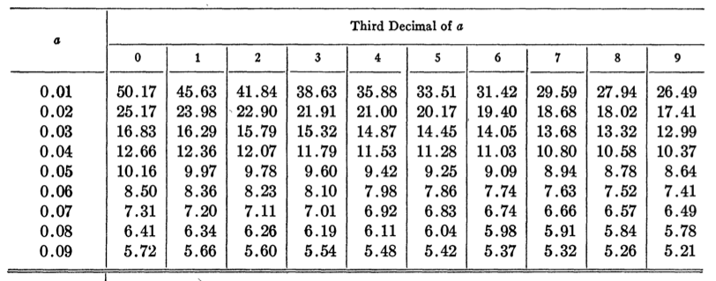

$\hat{γ}$ = 11.79

Now that $\hat{γ}$ has been found, an estimate for $λ$ can be found by taking the partial derivate of the likelihood function with respect to $λ$.

$\frac{∂L}{∂λ}$ = $\frac{N(γ-1)}{λ}$- $\sum_{i=1}^{N}{t_{i}}$ + $\frac{N}{λ}$ = 0

+ =

=

= .00000847

**Part C)**

**Statement of Problem:**

Calculate the goodness of fit value of ${ χ}^{2}$ using the formula from class. Show clearly the numbers used in the sum and how you arrived at the degrees of freedom.

**Solution:**

The idea behind the ${ χ}^{2}$ goodness of fit test is to divide the data up into sub-intervals. Then the points that are observed to fall into that sub-interval ( $O_{i})$ are compared to the expected number of points ($E_{i})$ for that that sub-interval. The equation used to find the goodness of fit value can be seen below as Eq. 6.

${ χ}^{2}$ = $\sum_{i=1}^{K}{(\frac{(O_{i}-{E_{i})}^{2}}{E_{i}}})$

Eq. 6

Where,

$E_{i}$ = N $P_{i}$

*

with N being the number of samples, $P_{i}$ being the probability that a data point will fall within an interval.

In Figure 1, the expected vs. observed C.D.F can be seen. From this plot the values in Table 2 were found. In Table 2, the observed and expected values for the goodness of fit test can be seen. At the bottom of Table 2 it can be seen that the ${ χ}^{2}$ value is approximately 4.08.

The method for which I arrived at the degrees of freedom can be seen below as Eq. 7.

DOF = k-1-t

Eq. 7

Where k is the equal to the number of bins, k = 9 in this case, and t is equal to the number of fitted parameters, t = 2 in this case. Thus,

DOF = 9-1-2 = 6

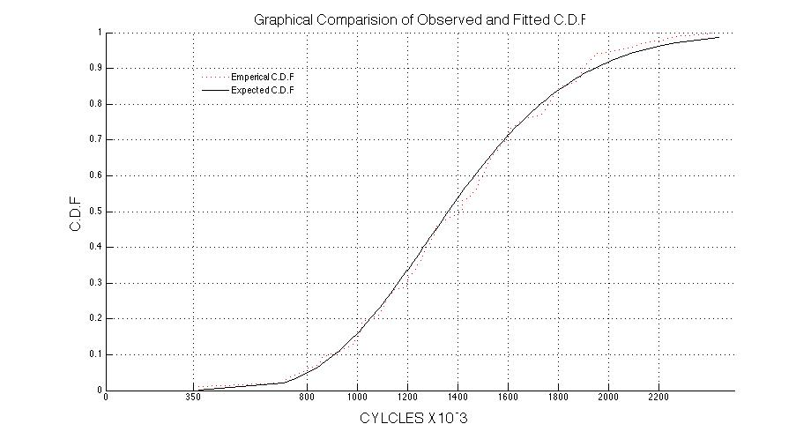

Figure 1: Expected vs Observed C.D.F.

Table 2: Goodness of Fit

|  |  |  |  |  |  |  |
| --- | --- | --- | --- | --- | --- | --- |
| **Bin** | | **Observed** | | **Expected** | | **(( O - E )^2) / E** |
|
|
| 1 | | 6 | | 5 | | 0.2 |
|
| 2 | | 8 | | 11 | | 0.818181818 |
|
| 3 | | 15 | | 18 | | 0.5 |
|
| 4 | | 20 | | 20 | | 0 |
|
| 5 | | 21 | | 16 | | 1.5625 |
|
| 6 | | 14 | | 14 | | 0 |
|
| 7 | | 10 | | 8 | | 0.5 |
|
| 8 | | 3 | | 4 | | 0.25 |
|
| 9 | | 3 | | 4 | | 0.25 |
|
|  |  |  |  |  |  | χ^2 = 4.081 |

**References:**

**[1]** Chapman, D. G., “Estimating the parameters of a truncated Gamma distribution,” Annals of Mathematical Statistics 27 (1956), 198-506.